**Cantata BWV 110, “*Unser Mund sei voll Lachens*” by J.S. Bach**

The term *Cantata* was introduced by Lutheran theologian and poet Erdmann Neumeister in 1700, a new kind of sacred text for musical setting.[1] Bach’s Cantatas are usually written for a baroque orchestra consisting of a string section, oboe section, and basso continuo with organ; timpani and brass are sometimes added.[2] On the top of instrumental parts, vocal parts included 4-part choir and vocal soloists also play a vital role in constituting to the cantata form. Most of Bach’s Cantatas were composed in Leipzig years (1723 – 1750) when he was appointed as the director of church music in several churches such as Saint Thomas’s and Saint Nicholas’s, and he produced cantatas every Sundays and holidays.[3] This essay will focus on the relationship between the text and the music, the instrumentation, and the formal structure based on Bach’s Cantata BWV 110, “*Unser Mund sei voll Lachens*”.

Cantata BWV 110, “*Unser Mund sei voll Lachens*” is a Christmas cantata, composed performed on the Christmas Day 1725. The texts of the cantata are taken from Psalms 126:2-3, Jeremiah 10:6, Luke 2:14, *Wir Christenleut* by Caspar Füger, and the cantata *Gottgefälliges Kirchen-Opffer* by Georg Christian Lehms.[4] The cantata is structured in seven movements and they are almost symmetrical in order: Opening Chorus – Aria – Recitative – Aria – Duet – Aria – Closing Chorale.[5] Bach scored the cantata for a four-part choir, vocal soloists, and a Baroque ensemble consisted of three trumpets, timpani, two transverse flutes, three oboes (including oboe d’amore and oboe da caccia), two violins, viola, and basso continuo (including organ and bassoon). The instrumentation across the seven movements is also symmetrical, as it begins with all instruments together, then the instrumental forces and counts diminish towards the middle of the cantata, but instruments slowly join back in in the end of the work.

The first movement in the Cantata is a paraphrase of Psalm 126:2-3, which is about the psalmist expressing his hope for the captives of Zion.[6] The movement opens with a slow majestic orchestral prelude with trumpets call, reflecting the text “the lord hath great-things for us done”. In addition, this movement is an adaption of Bach’s Overture in D major, BWV 1069, with trumpets, timpani and flutes added.[7] This is followed by a fast choral section with the call for laughter and praise. The verse “Unser Mund sei…” indicates that there are many people celebrating together in a place, especially the word “unser” (our). For this verse, Bach applied the fugal texture to creates the ambient soundings of people laughing and talking. In contrast, the following text “Denn der Herr…” is more stable in rhythm, which helps the message from the text to deliver clearly. Meanwhile, the instrumentation has been changed and reduced to wind instruments only. Besides, it is marked *senza ripieni* for vocal part in this verse. In bar 128, there is a solo Bass with strings and basso continuo with organ, which sounds like the priest is delivering a great message in the church. This movement ends with a slow orchestral postlude.

Figure 1 J.S. Bach, Cantata BWV 110, “Unser Mund sei voll Lachens”, First movement, Bars 128 – 133

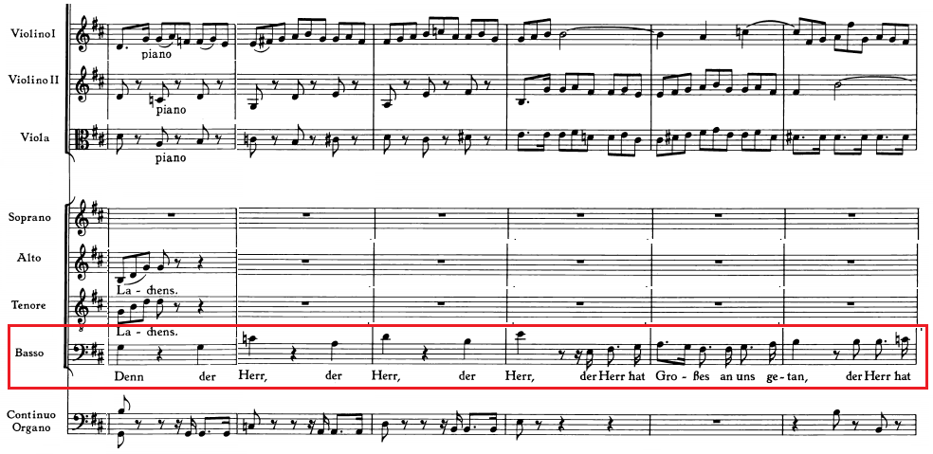

The second movement’s text is associated with the soaring thoughts and senses of the man.[8] This is a Tenor aria “Ihr Gedanken und ihr Sinnen”, accompanied by two transverseflutes and basso continuo with organ. The opening flutes represents the lowly birth of God’s son.[9] The aria is run by a binary form, with some words show the use of word painting. For example, the words “Himmelan” or “Himmels” (Heaven) are set in the higher notes, also “Steiget Schleunig” (Climb Quickly) and “Schwinget” (Soar-aloft) have the ascending movement.

Figure 2 J.S. Bach, Cantata BWV 110, “Unser Mund sei voll Lachens”, Second movement, Bars 21 – 22

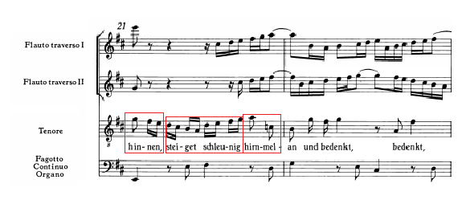

Figure 3 J.S. Bach, Cantata BWV 110, “Unser Mund sei voll Lachens”, Second movement, Bar 12

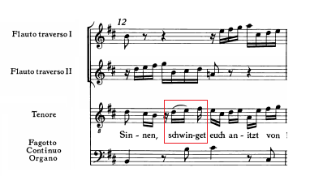

The third movement is the shortest movement in the work, with only five bars long. The text is another biblical passage, which is taken from Jeremiah 10:6.[10] This is a Bass recitative “Dir, Herr, ist niemand gleich”, accompanied by the strings and basso continuo with organ. An impression of the man looking at the sky and sing is presented by the string playing ascending movement, also the man mentioned the words “you” many times, indicating that “you” is the Lord. Additionally, the word “Groß” (Great) is accented by setting it on the higher note. Also, when the Bass sings “Groß”, the harmony changes.

Figure 4 J.S. Bach, Cantata BWV 110, “Unser Mund sei voll Lachens”, Third movement, Bars 1 – 2

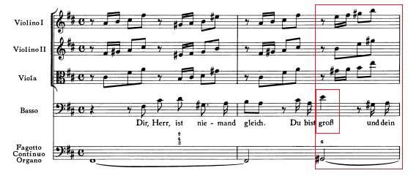

The fourth movement is an aria for Alto, “Ach Herr, was ist ein Menschenkind”. This movement’s text expresses the wonder about the nature of man when the Lord should seek to save him through such painful action.[11] An obbligato oboe d’amore and basso continuo with organ are the only instruments in this movement. Interestingly, a call-and-response is observed between the oboe d’amore and the alto. The form of this movement is, again, in binary form, which functions as separating the curse and the redemption that is mentioned in the text.[12] The word “Herr” (Lord) is always preceded by “Ach” (Ah) to make a leap for emphasizing the word “Herr”. Besides that, the words “Höll” (Hell) in bar 36 and “Wurm” (Worm) in bar 38 are coloured by diminished harmony.

Figure 5 J.S. Bach, Cantata BWV 110, “Unser Mund sei voll Lachens”, Fourth movement, Bars 17 – 19

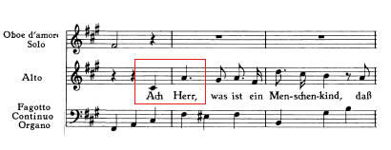

Figure 6 J.S. Bach, Cantata BWV 110, “Unser Mund sei voll Lachens”, Fourth movement, Bars 32 – 34

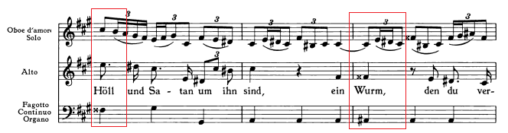

The fifth movement is a duet with Soprano and Tenor, “Here sei Gott in der Höhe”, which simply accompanied only by basso continuo with organ. The text of this movement is drawn from the Christmas story in Luke 2:14, which is about they offer to god’s glory in the highest as peace on Earth is awaited now that the child has come as assign of favour.[13] The music is based on the *Virga Jesse floruit* from the Magnificat; however with a change on the vocal lines by setting them to different texts.[14] With a faster rhythmic drive and text alteration, the atmosphere of this movement undergo a drastic change to a more lively and celebratory mood.

The sixth movement is a Bass aria “Wacht auf, ihr Adern und ihr Glieder”, which is follows the story of waking people up to join the praise of the angels; the trumpet does the work for waking people up. The oboes double the strings to intensify the dynamic spectrum, which accentuates the word “Wacht auf” (Wake up). The Bass begins with the imitation of the opening line by trumpet. The form of this aria is in “free” da capo, which means the returning of Section A is varied. Notably, The Section B sounds like the ending of the movement, due to it ends with a perfect cadence by the Bass and basso continuo with organ. However, the returning of Section A strikes back with the trumpets unexpectedly, to wake people up.

The final movement, all the instruments including choir are now “awake”. Yet, the instruments do not have their own lines, but instead they share the same melodies with the choir. The text is drawn from the fifth verse of the hymn *Wir Christenleut* by Caspar Füger.[15]

In conclusion, Bach’s Cantata BWV 110, “*Unser Mund sei voll Lachens*” has demonstrated how the music is dominated by the text. From the analysis of this work, Bach’s setting of the religious text is shown by the use of word painting and instrumentation. Besides that, Bach also uses the movement of the music draw parallel to the meaning of the text. For example, the ascending movement in the strings representing the man singing to the sky in third movement. Also, Bach uses the texture of music to illustrate the text, which shown in the first movement with choir singing in fugal texture to create the sounds of people laughing. Through this work and many other vocal works, Bach has influenced the later composers, such as Mozart, Beethoven and Schubert, by how he valued the text and using the music to colour the text.

1. Burkholder, Peter J, Grout, Donald Jay, and Palisca, Claude V: *A History of Western Music*, 9th edition. (New York and London: W.W. Norton and Co., 2014), 443.
2. Krummacher, Friedhelm.: ‘Cantata: The German cantata to 1800’, Grove Music Online (Oxford University Press, 2001), accessed 4 November 2019, <https://doi-org.tudublin.idm.oclc.org/10.1093/gmo/9781561592630.article.04748>.
3. Burkholder, Peter J, Grout, Donald Jay, and Palisca, Claude V: *A History of Western Music*, 437, 443.
4. Unger, Melvin P.: *Handbook to Bach’s Sacred Cantata Texts* (Maryland: Scarecrow Press, Inc., 1996), 387-289.
5. DüTop of FormBottom of Formrr, Alfred: *The Cantatas of J.S. Bach: With Their Librettos in German-English Parallel Text* (Oxford: Oxford University Press, 2006), 98.
6. *Ibid.*
7. *Ibid, 99.*
8. Unger, Melvin P.: *Handbook to Bach’s Sacred Cantata Texts*, 387.
9. DüTop of FormBottom of Formrr, Alfred: *The Cantatas of J.S. Bach: With Their Librettos in German-English Parallel Text*, 99.
10. Unger, Melvin P.: *Handbook to Bach’s Sacred Cantata Texts*, 387.
11. *Ibid*, 388.
12. DüTop of FormBottom of Formrr, Alfred: *The Cantatas of J.S. Bach: With Their Librettos in German-English Parallel Text*, 99.
13. DüTop of FormBottom of Formrr, Alfred: *The Cantatas of J.S. Bach: With Their Librettos in German-English Parallel Text*, 98.
14. *Ibid*, 99.
15. DüTop of FormBottom of Formrr, Alfred: *The Cantatas of J.S. Bach: With Their Librettos in German-English Parallel Text*, 99.